**DEVELOPMENT OF WEBSITE FOR GITAM**

**Agenda for the application:**

The following Application is useful to provide the basic information about the training and placement cell of GITAM university Hyderabad campus and it is also useful for the institution for several activities like:

1. To get the feedback from the people
2. To make people to sign on to their website
3. To provide several facilities regarding there institution to others by giving access to people by their login page.

**Data to be captured:**

1. Login Id
2. Password

**The following data is captured from the students of GITAM for giving the access to their site.**

**Software Requirements:**

**HTML and CSS.**

**Wireframes:**

A wireframe is a schematic or blueprint that is useful for helping you, your programmers and designers think and communicate about the structure of

the software or website you're building

**Home Page:**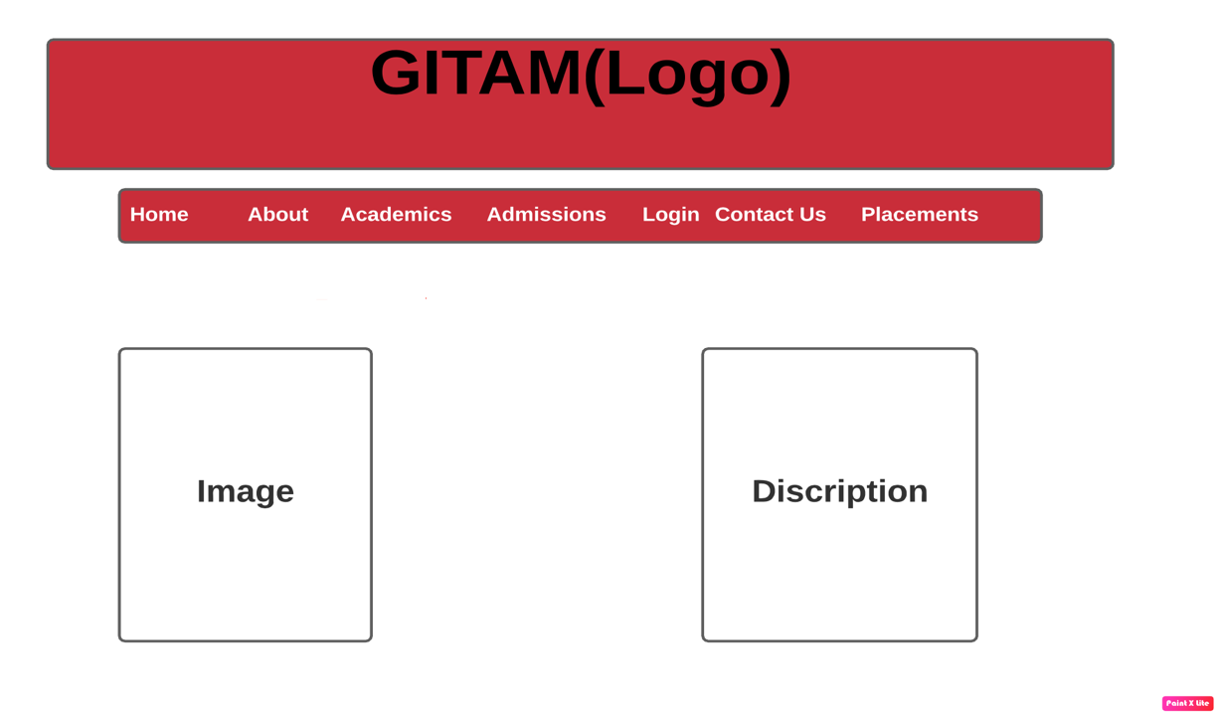

**About Page:**

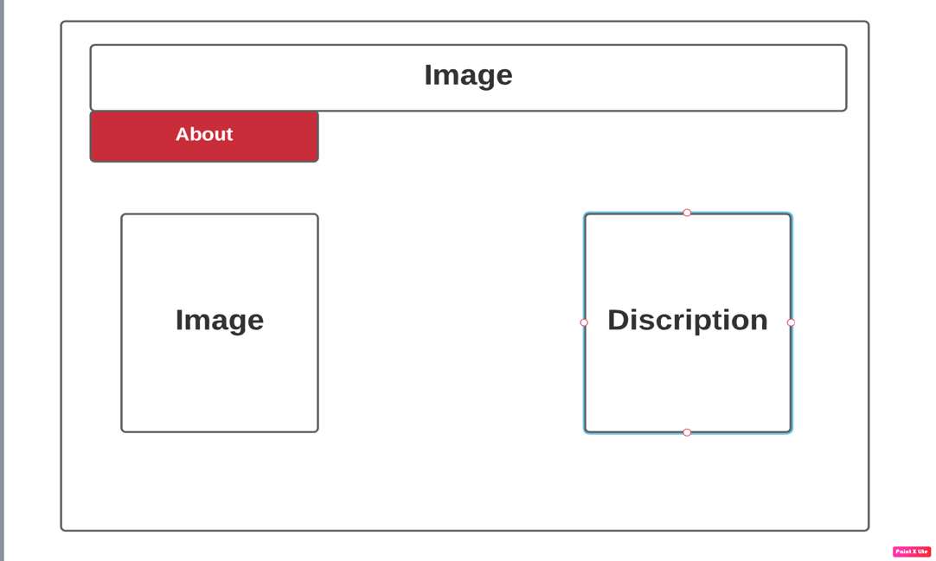

**Academics Page:**

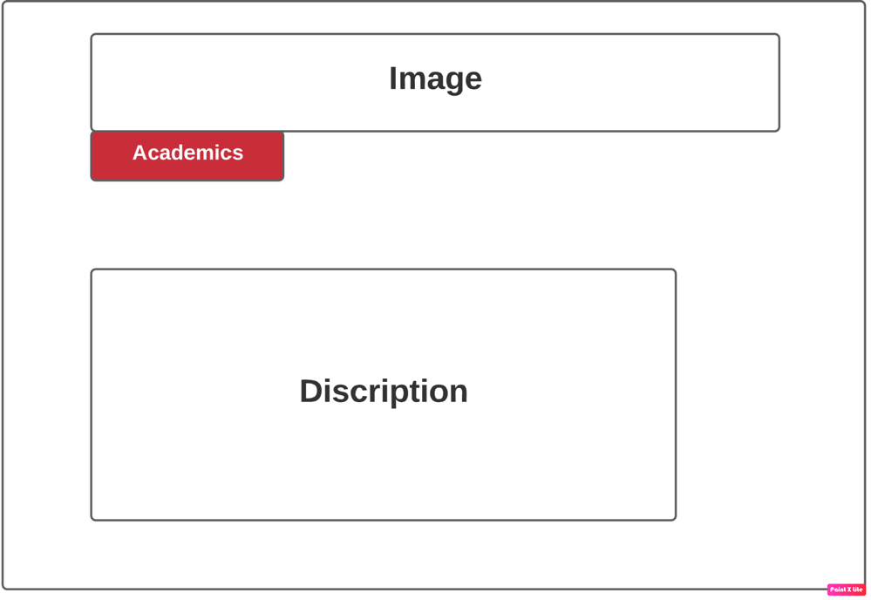

**Admission Page:**

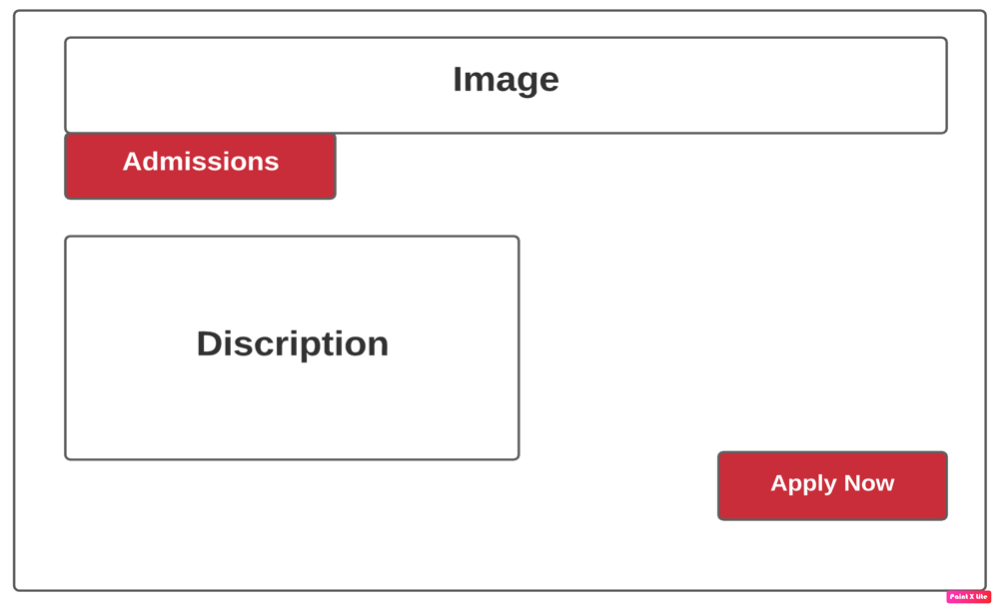

**Login Page:**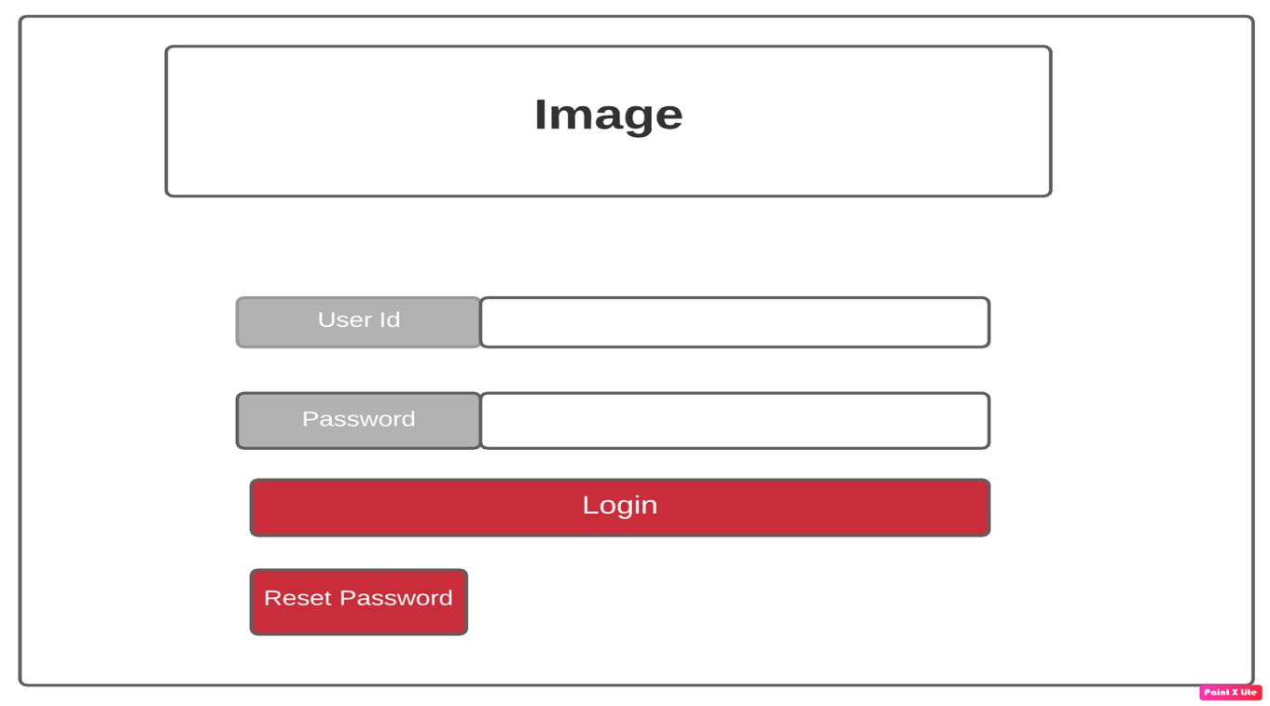

**Placements:**

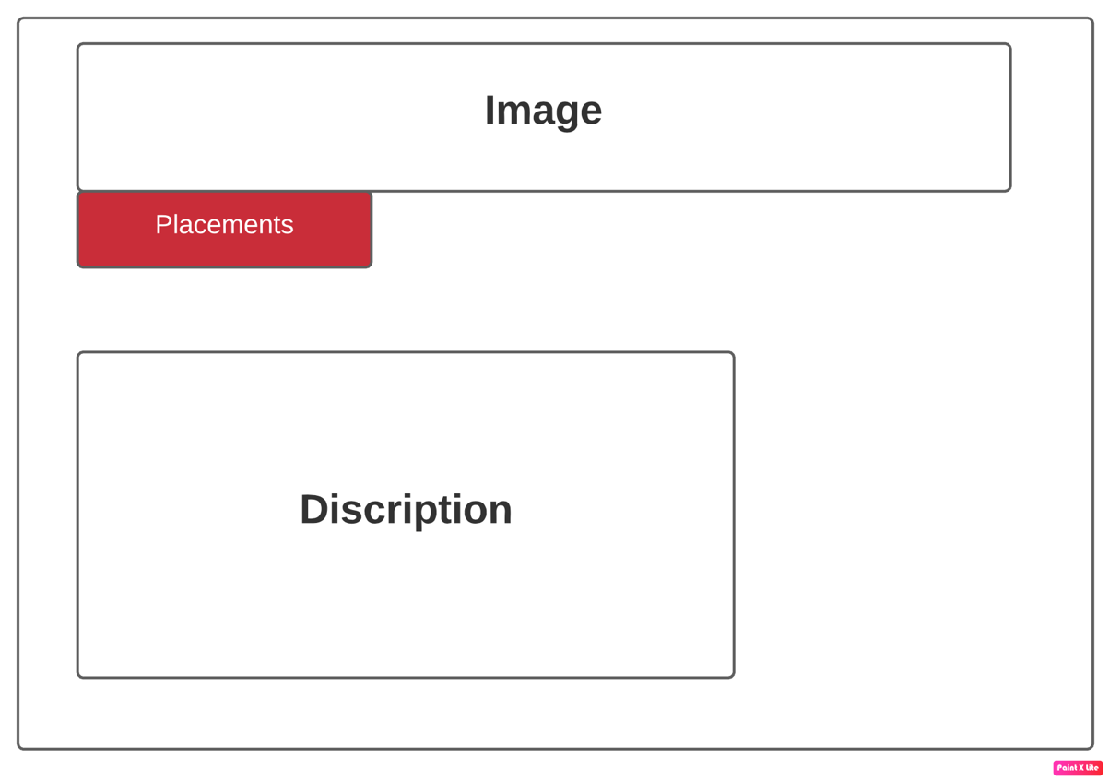

RESULT

Home Page:

The Subpages present in the home page are:

1. **Home**
2. **About**
3. **Login**
4. **Contact us**
5. **Feedback**
6. **Registration**

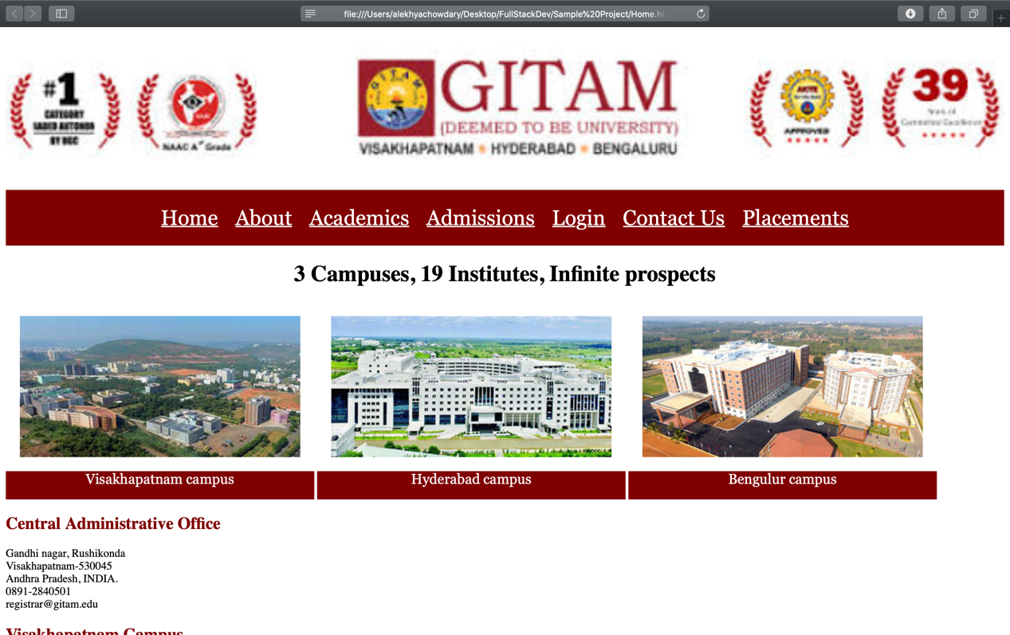

Page 2: About us

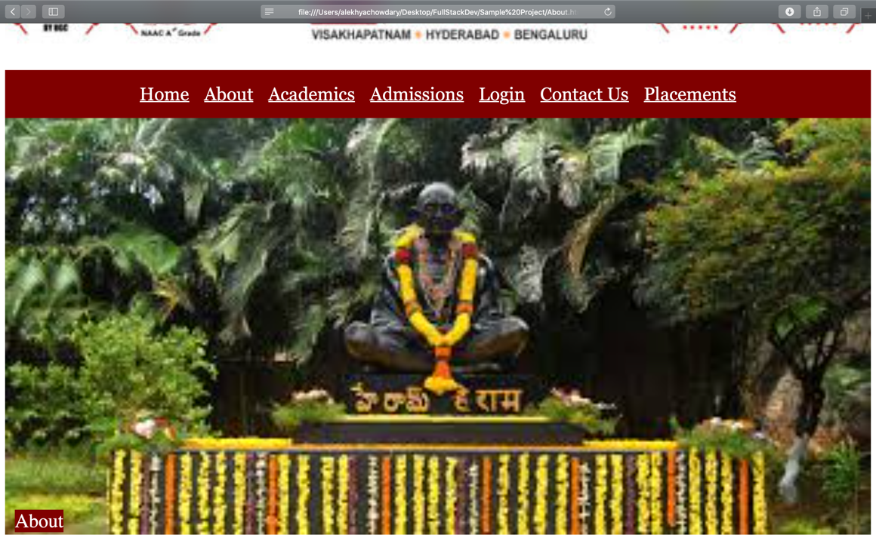

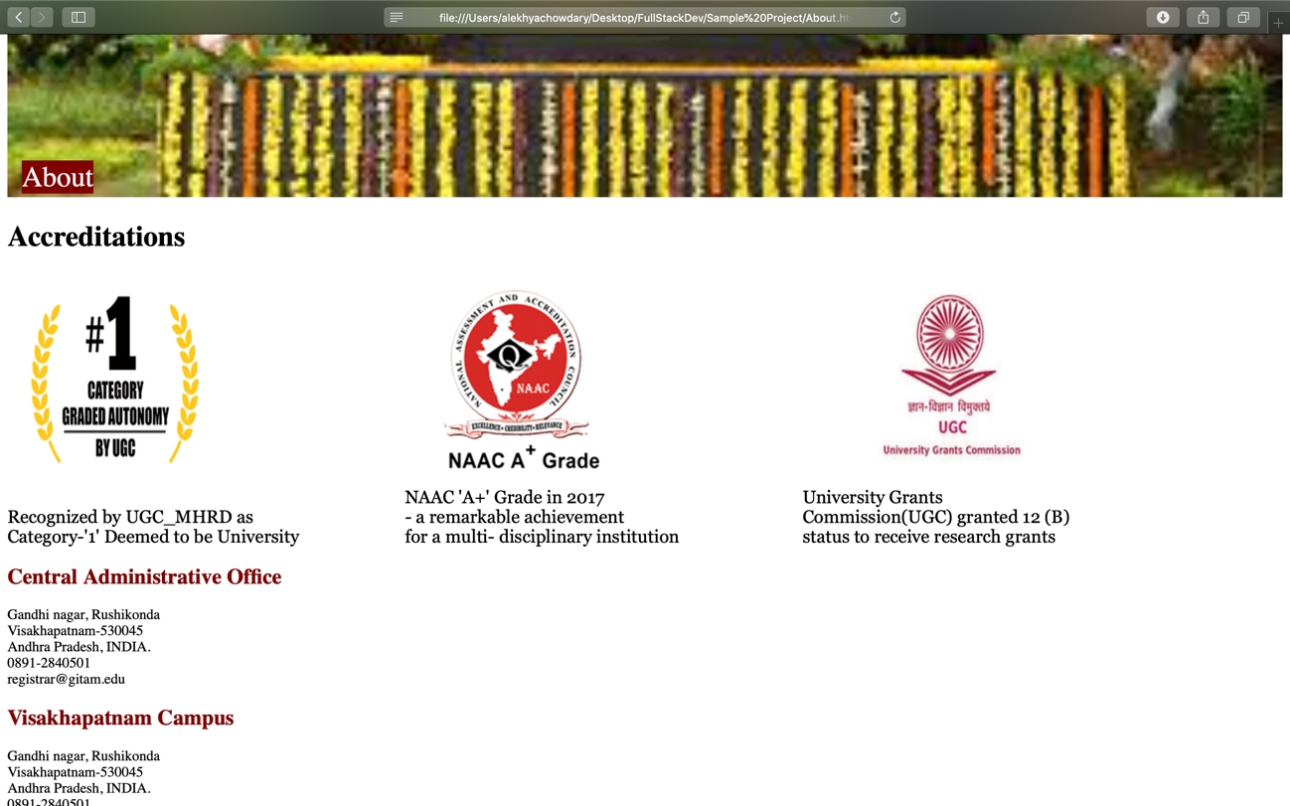

Page 3:

Contact us



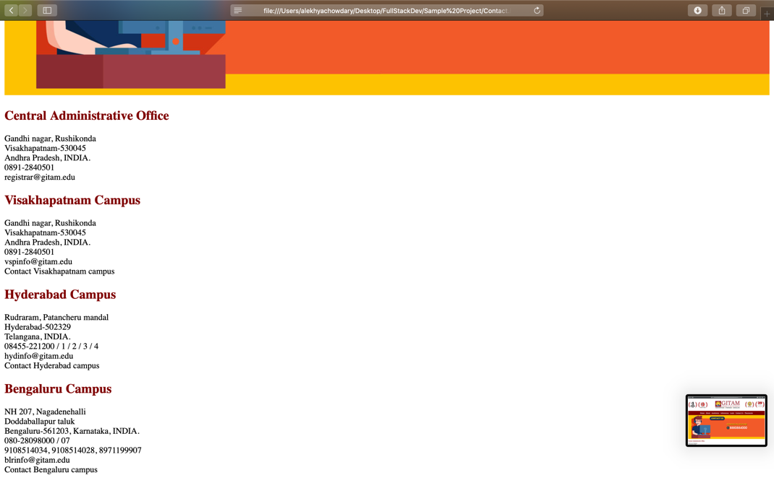

pa Page 4:

LOGIN

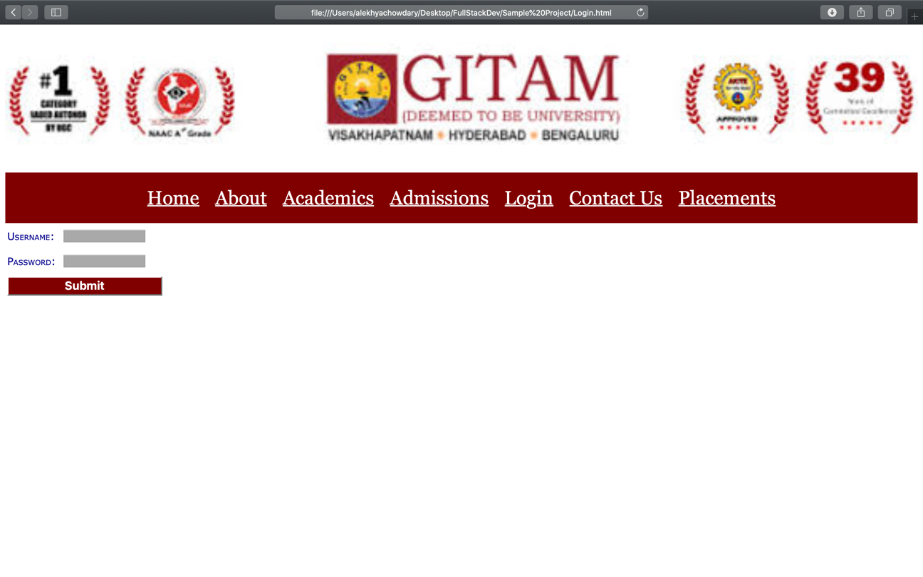

pa Page 5:

Admissions



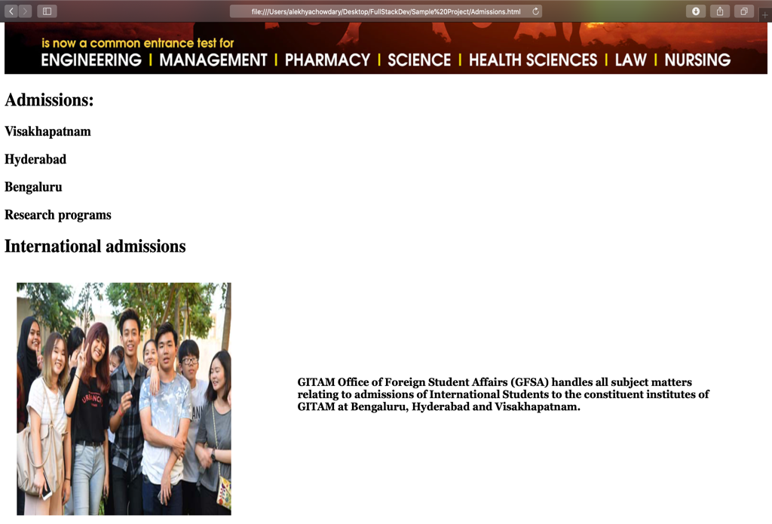

pa Page 6:

Academics

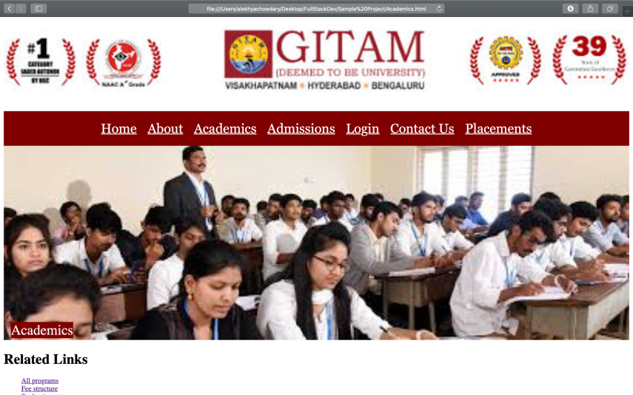

pa Page 7:

Placements



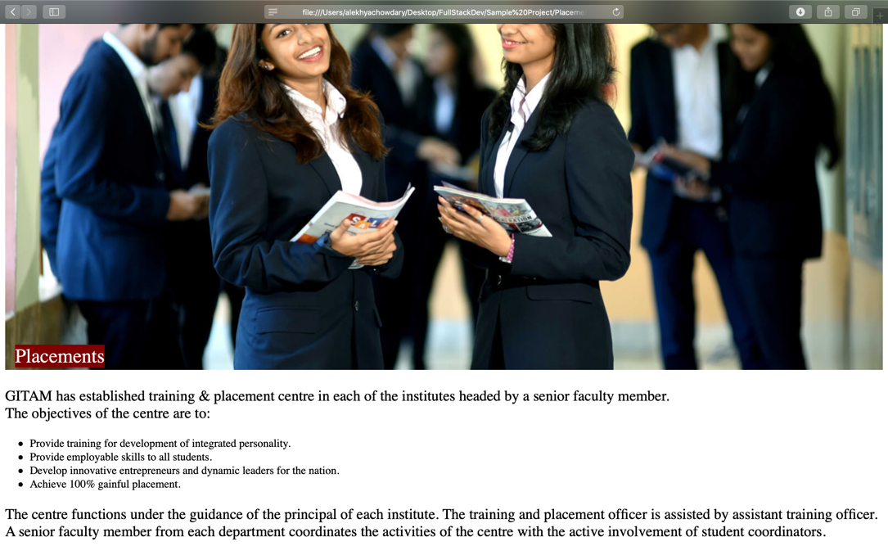

Conclusion:

The following page is totally useful for educational and for Advertising Purpose.